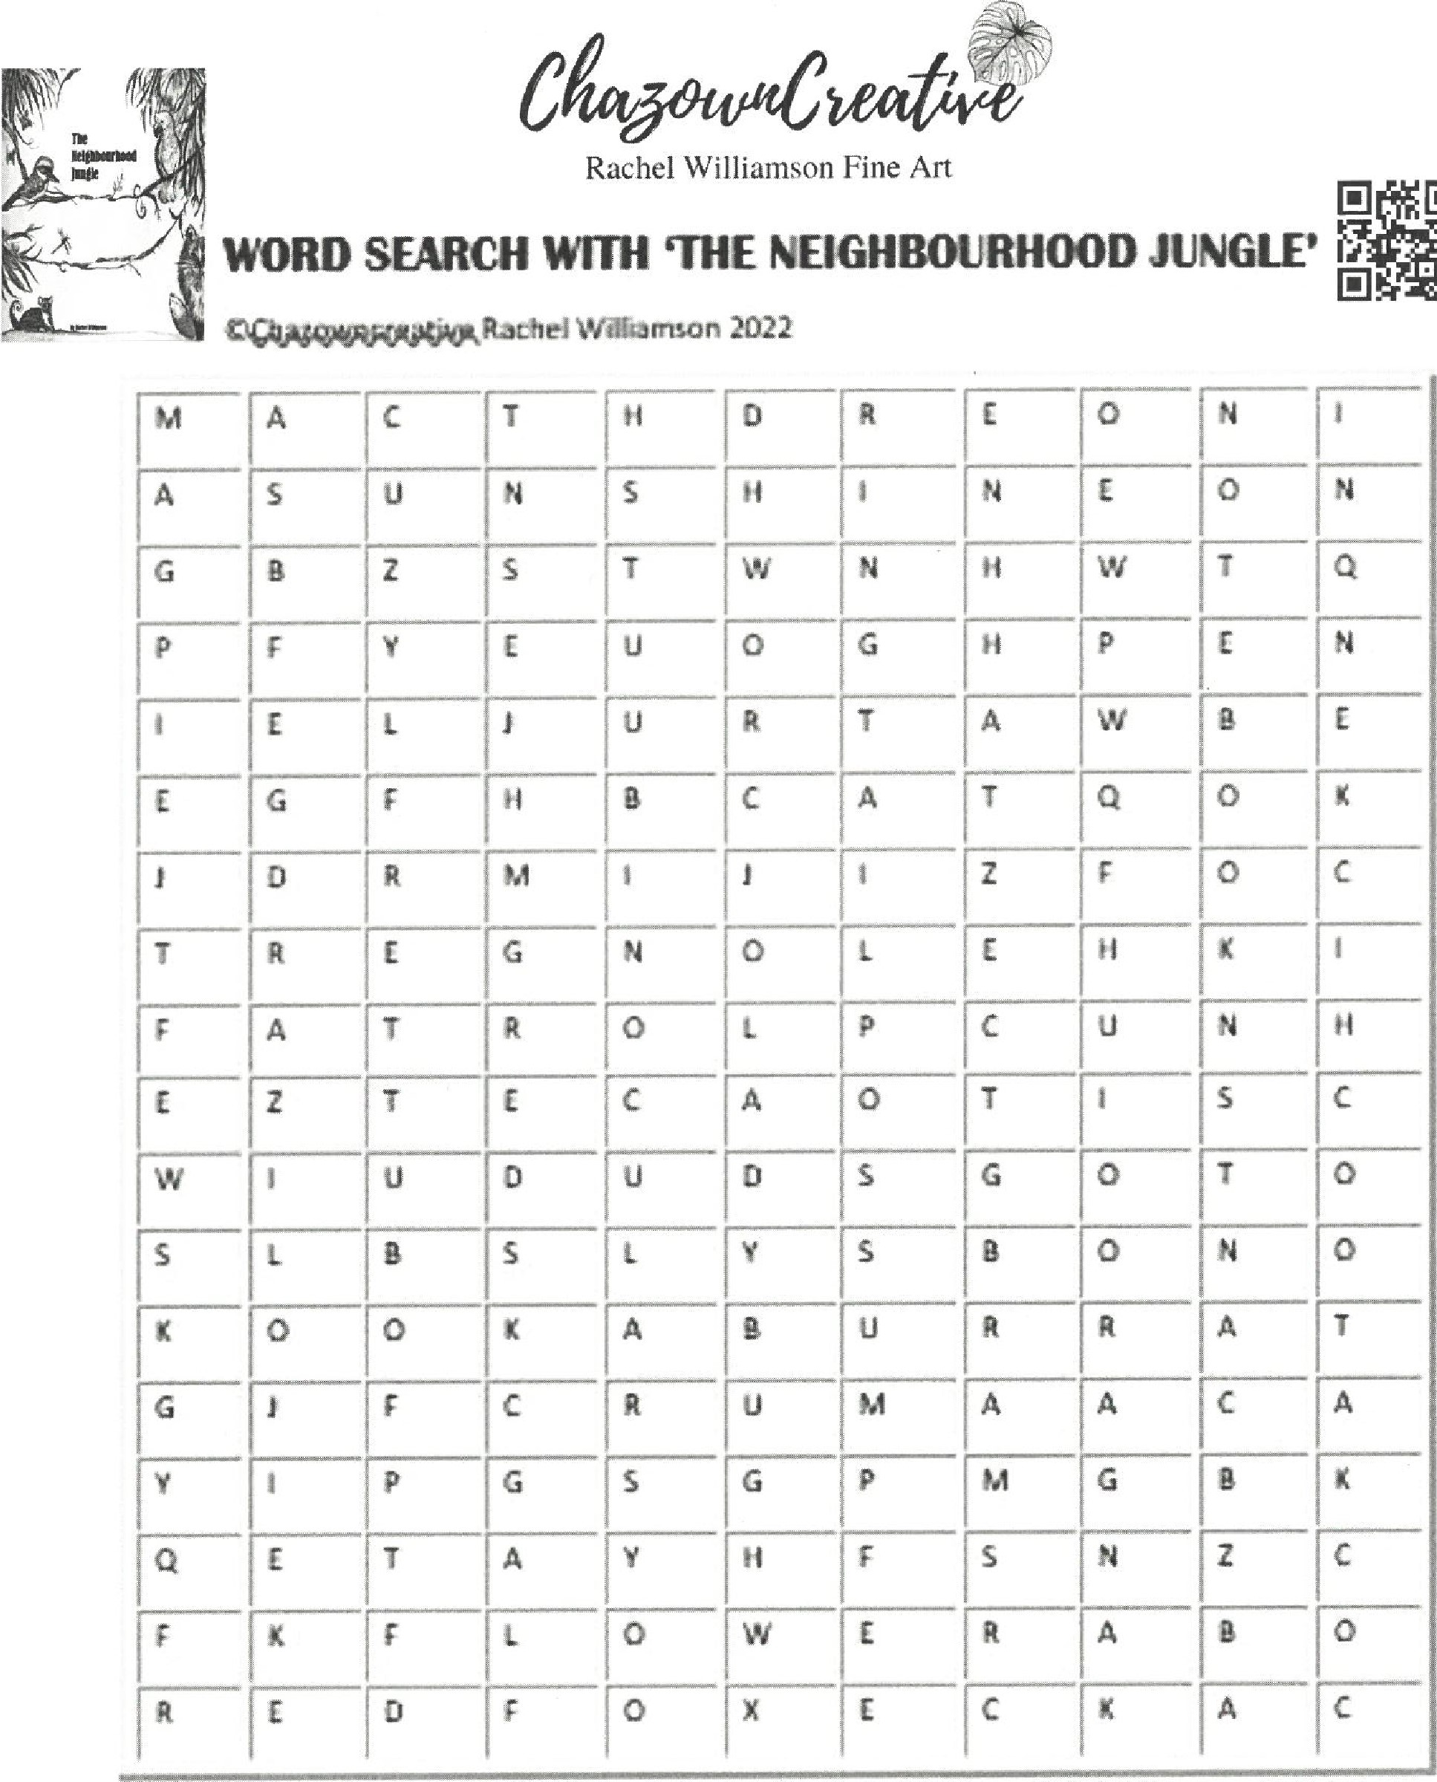
©ChazownCreative Rachel Williamson
WORDS:
Red fox | Notebook | Binoculars | LadyBug
Ringtail possum | pen | Butterfly | Flower
Cat | Ants | Chicken | Sunshine
Cockatoo | Magpie | Kangaroo | Lizard
Kookaburra | Hat | Flag | Crow

